Gastroesophageal Reflux Disease Treatment & Management-H1
Author : Dr. Abhijeet Karad, Consultant, Gastroenterology

Priority | Search Volume | Keyword Intent | ASV
P1 | gastroesophageal reflux disease | Informational | 74000
P1 | gastroesophageal reflux disease symptoms | Informational | 49500
P1 | gastroesophageal reflux treatment | Informational | 18100
P1 | gastroesophageal reflux disease causes | Informational | 2900
P1 | medicine for gastroesophageal reflux disease | Informational | 880
P1 | reason for gastroesophageal reflux disease | Informational | 1600
P1 | gastroesophageal reflux disease remedies | Informational | 320

Title- GERD: Symptoms, Causes, Treatment & Reasons for Acid Reflux
Description- Manage GERD effectively with lifestyle changes, medications, and surgery options. Understand symptoms, causes, and treatments to improve quality of life.
Slug- /gerd-symptoms-causes-treatment
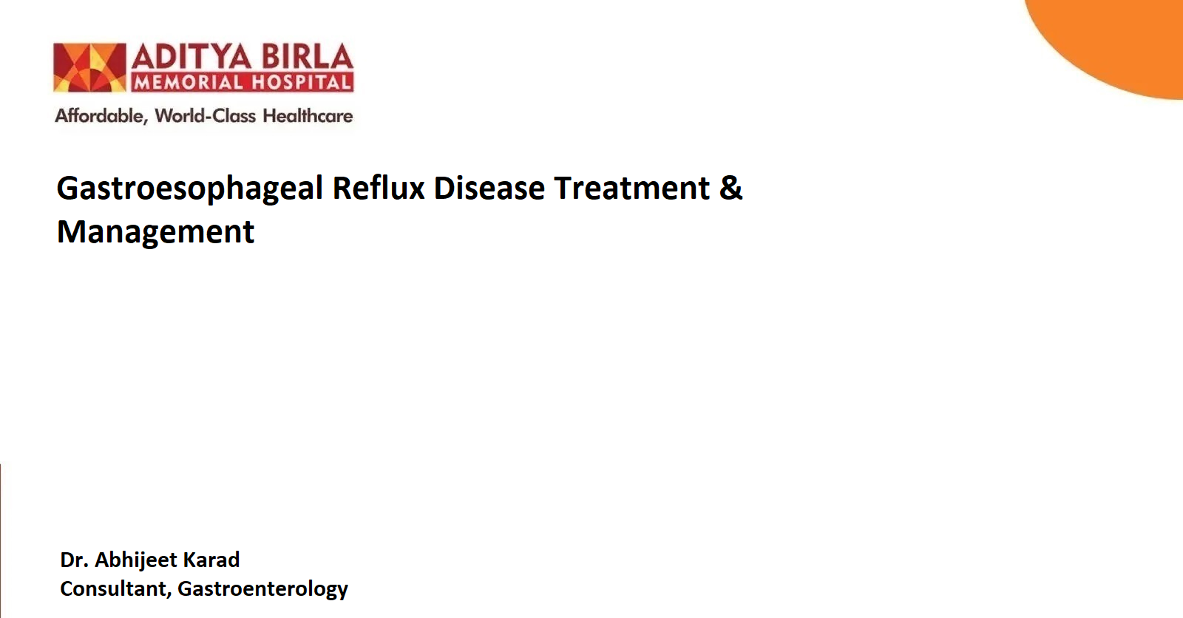

Gastroesophageal reflux disease (GERD) is a common condition affecting many individuals globally, often leading to significant discomfort and interruptions in daily routines. If you've ever felt a burning sensation in your chest or a sour taste lingering in your mouth, you’ve likely encountered some of the distressing symptoms of GERD.
However, GERD goes beyond the occasional episode of heartburn. It is a chronic condition that requires proper treatment and management to avoid serious complications, such as oesophageal damage or difficulty swallowing.
In this guide, we will explore what GERD is, its symptoms, causes, diagnosis, and various treatment and management options.

What is GERD?-H2
Gastroesophageal reflux disease is a digestive condition where stomach acid or bile irritates the oesophagus. This occurs when the lower oesophageal sphincter (LES), a muscle at the base of the oesophagus, weakens or fails to close properly.
The LES normally opens to let food into the stomach and closes to prevent contents of the stomach from moving back up into the oesophagus. In GERD, the LES does not function properly, allowing stomach acid to flow upward and irritate the oesophagus.
GERD is a more severe and chronic form of acid reflux, a common condition where stomach acid occasionally moves into the oesophagus. If left untreated, GERD can lead to significant health problems, including chronic esophagitis, ulcers, and even oesophageal cancer.

Symptoms of GERD-H2
Gastroesophageal reflux disease symptoms range from mild to severe, and they can vary based on the stage of the condition.

Common Symptoms

Heartburn: A burning feeling in the chest, usually after eating, especially when lying down. It occurs due to stomach acid irritating the oesophagus.

Regurgitation: The sensation of stomach acid or food backing up into the throat or mouth, often leaving a sour taste.

Chest Pain: Discomfort in the chest that can feel like tightness, often mistaken for heart-related issues. It worsens after eating or at night.

Difficulty Swallowing (Dysphagia): A sensation of food getting stuck in the throat or chest, caused by irritation or narrowing of the oesophagus from acid reflux.

Symptoms Based on Stages of GERD-H2
- Mild GERD: Occasional heartburn, usually after meals, that can be managed with lifestyle changes.
- Moderate GERD: Frequent heartburn, regurgitation, and discomfort that may affect sleep or daily activities.
- Severe GERD: Chronic symptoms that interfere with daily life, along with potential complications like ulcers or bleeding in the oesophagus.
It's important to note that some people with GERD may not experience the classic symptoms like heartburn. Instead, they might experience atypical symptoms, such as a chronic cough, sore throat, hoarseness, or asthma-like symptoms.

Gastroesophageal Reflux Disease Causes-H2
There are several factors that can contribute to gastroesophageal reflux disease.
- Weak Lower Oesophageal Sphincter (LES): The LES acts as a valve between the oesophagus and stomach. When weakened, it allows acid to flow back into the oesophagus, the primary cause of GERD.
- Hiatal Hernia: When the upper part of the stomach pushes through the diaphragm into the chest, it can weaken the LES, increasing the risk of acid reflux.
- Obesity: Excess weight can put pressure on the abdomen, pushing stomach contents up into the oesophagus.
- Pregnancy: Hormonal changes and the growing uterus can increase pressure on the stomach, leading to acid reflux.
- Delayed Stomach Emptying: If food stays in the stomach for too long, it can cause bloating and increase the likelihood of reflux.
- Lifestyle Factors: Smoking, alcohol consumption, and certain foods can weaken the LES and trigger acid reflux.
- Medications: Some medications, like aspirin, ibuprofen, and certain blood pressure medications, can relax the LES and increase the risk of GERD.

Diagnosis of GERD-H2
If you experience frequent acid reflux symptoms, it's essential to see a doctor for an accurate diagnosis. The gastroenterologist may perform several tests to confirm gastroesophageal reflux disease symptoms and rule out other conditions.
Some common diagnostic tests include:
- Endoscopy: A thin, flexible tube with a camera is inserted into the oesophagus to check for damage, inflammation, or other complications of GERD.
- Ambulatory pH Monitoring: This test measures the acidity in the oesophagus over 24-48 hours to track acid reflux.
- Barium Swallow: This X-ray test helps to identify any structural issues in the oesophagus or stomach.
- Oesophageal Manometry: A test that measures the pressure and movement of the oesophagus to check if the LES is functioning properly.

Treatment and Management of GERD-H2
Effective gastroesophageal reflux treatment involves a combination of lifestyle changes, medications, and in some cases, surgery. Here’s an overview of the common treatment options:

Lifestyle Modifications-H3
- Dietary Changes: Avoid trigger foods like spicy foods, citrus, tomatoes, chocolate, peppermint, alcohol, and caffeine.
- Weight Management: Losing excess weight can reduce pressure on the stomach and help alleviate symptoms.
- Avoid Late Meals: Try not to eat at least 2-3 hours before bedtime to allow the stomach to empty before lying down.
- Elevate the Head of the Bed: Sleeping with the head of the bed elevated can help reduce nighttime acid reflux.
- Quit Smoking: Smoking weakens the LES and exacerbates GERD symptoms.

Medications for GERD-H3
There are several types of medicine for gastroesophageal reflux disease that can help control symptoms:
- Antacids: These over-the-counter medications neutralize stomach acid and provide quick relief from heartburn.
- H2-Receptor Antagonists: These medications help decrease acid production by blocking histamine receptors in the stomach lining. They are commonly used for mild to moderate gastroesophageal reflux disease treatment, providing longer-lasting relief than antacids.
- Proton Pump Inhibitors (PPIs): These drugs reduce stomach acid production more effectively and are commonly prescribed for GERD management.
- Prokinetics: These medications help your stomach empty faster, which can reduce the chances of acid reflux.

Surgery for GERD-H3
If lifestyle changes and medications fail to provide relief, surgical intervention may be an option. Here are two common surgical procedures for gastroesophageal reflux disease treatment:
- Fundoplication: In this procedure, the top portion of the stomach is wrapped around the lower oesophagus. This strengthens the lower oesophageal sphincter (LES), preventing acid reflux.
- LINX Surgery: This involves implanting a small magnetic ring around the LES. The ring keeps the sphincter closed while allowing food and liquids to pass through when swallowing.

How to Avoid GERD?-H2
Preventing GERD often involves making some simple lifestyle adjustments. Here are a few tips to help avoid GERD:
- Eat Smaller, More Frequent Meals: Large meals can increase stomach pressure and promote acid reflux.
- Stay Upright After Eating: Wait at least 2-3 hours before lying down to reduce the chance of acid reflux.
- Wear Loose Clothing: Tight clothes can put pressure on the abdomen, contributing to GERD symptoms.
- Avoid Smoking and Alcohol: Both smoking and alcohol relax the LES and increase acid reflux.

When to See a Doctor?-H2
If you experience symptoms like persistent heartburn, regurgitation, or chest pain, it’s important to consult a doctor.
A doctor should also be seen if:
- Symptoms persist despite over-the-counter medication.
- Difficulty swallowing or a sensation of food getting stuck in your throat.
- Unexplained weight loss or difficulty eating.
- Chronic coughing, hoarseness, or wheezing that doesn’t improve.
GERD can lead to complications if it is not treated. Complications include oesophageal ulcers, bleeding, and Barrett's oesophagus (a condition that can lead to oesophageal cancer). Addressing GERD early can help prevent these severe outcomes.

Conclusion-H2
Gastroesophageal reflux disease can significantly impact quality of life, but with proper treatment and lifestyle adjustments, most people can manage the condition effectively. By understanding the symptoms, causes, and available treatments, individuals can take control of their health and reduce the impact of GERD on their daily lives.
If you suspect you have GERD or experience frequent symptoms, it’s crucial to consult with a doctor to receive an accurate diagnosis and appropriate treatment plan.
If you are in the Pimpri-Chinchwad area, you can visit Aditya Birla Memorial Hospital to consult with a gastroenterologist.

FAQs-H2

How to Improve GERD Symptoms?-H3
Focus on dietary changes, maintain a healthy weight, and avoid lying down right after meals. Medication like PPIs or H2 blockers can also help manage symptoms effectively.

How Can I Stop GERD Permanently?-H3
While GERD is a chronic condition, lifestyle changes like dietary adjustments, weight management, and medication can significantly reduce symptoms. In severe cases, surgery might be recommended to provide lasting relief from GERD symptoms.

What Foods to Avoid with Acid Reflux?-H3
Avoid spicy foods, citrus fruits, chocolate, caffeine, alcohol, and fatty or fried foods, as these can trigger acid reflux.

How to Stop Acid Reflux Quickly?-H3
Taking antacids can provide quick relief from acid reflux. Drinking water or eating a small amount of alkaline foods like bananas may also help neutralize stomach acid.
References:
Definition & facts for GER & GERD [Internet]. National Institute of Diabetes and Digestive and Kidney Diseases. NIDDK - National Institute of Diabetes and Digestive and Kidney Diseases; 2022 [cited 2024 Nov 21]. Available from: https://www.niddk.nih.gov/health-information/digestive-diseases/acid-reflux-ger-gerd-adults/definition-facts
Gyawali CP, Fass R. Management of gastroesophageal reflux disease. Gastroenterology [Internet]. 2017;154(2):302–18. Available from: https://pubmed.ncbi.nlm.nih.gov/28827081/
Nih.gov. [cited 2024 Nov 21]. Available from: https://pmc.ncbi.nlm.nih.gov/articles/PMC6140167/#

